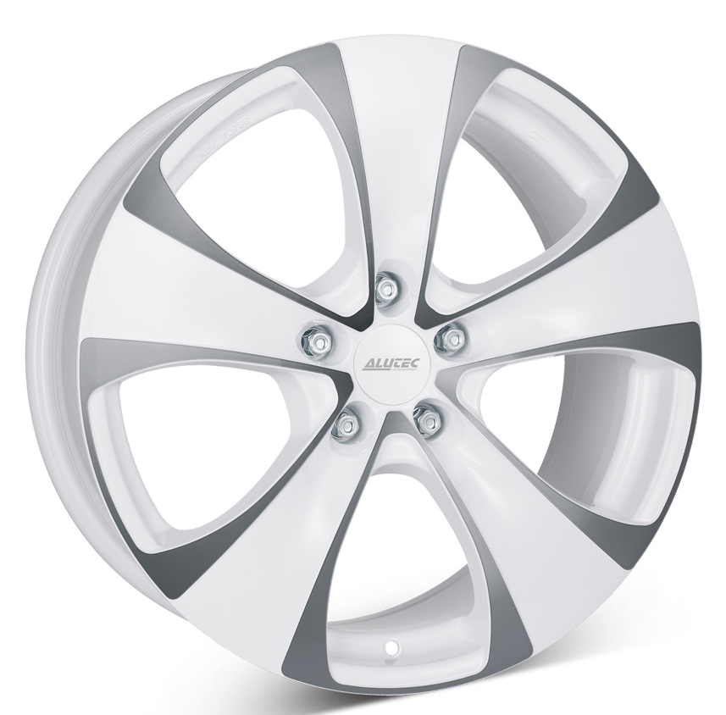
ALUTEC DYNMITE WHITE
8,5x18
5-114,3
NAV69
ET38
LEXUS
DEMOKÖRDA

PRIS: 1599KR/ST INKL MOMS & MONTERING

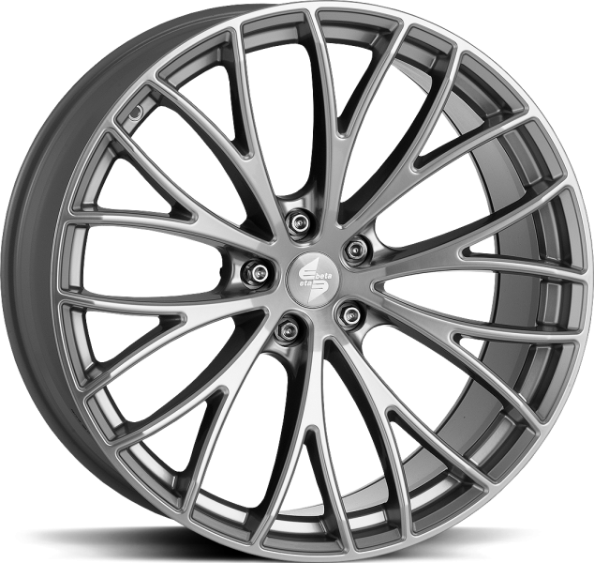
Etabeta Piuma Anthracite
8,5X18
5-120
NAV65,1
ET45

NYA 2250KR INK MOMS & MONTEING
PASSAR VW TRANSPORTER

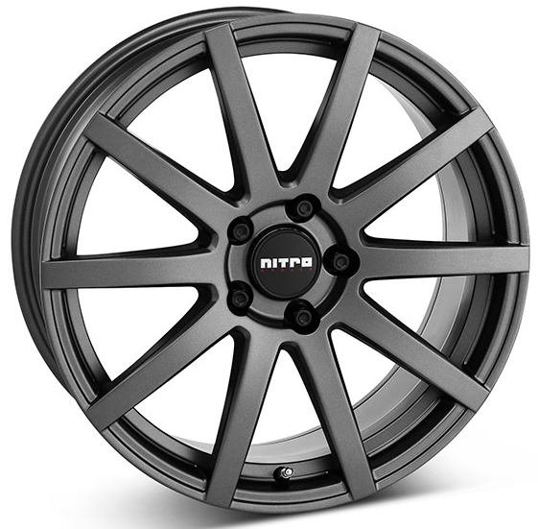
NITRO RAZOR M GUN
7X16
5-108
NAV 63,3
ET 45

PASSAR VOLVO

PRIS 950KR/ST + MOMS + MONTERING

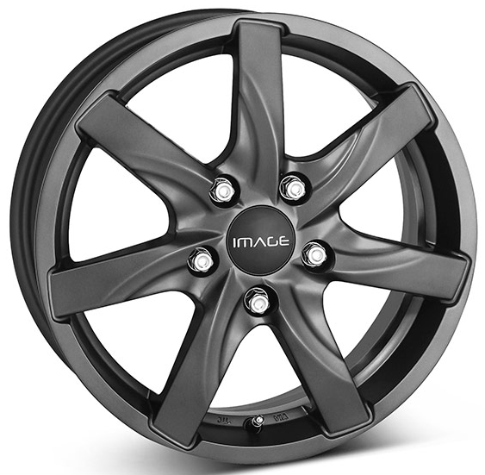
IMAGE ATLAS M GUN
16X6,5
5-130
NAV 78,1
ET62
RENAULT MASTER

PRIS 1450KR/ST + MOMS + MONTERING

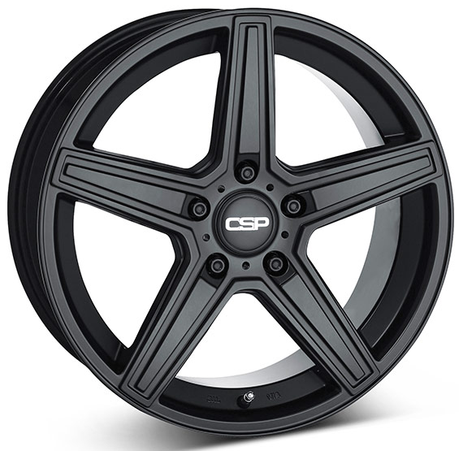
CSP 15 M BLACK
8X17
5-112
NAV 66,4
ET38
MERCA E KLASS

PRIS: 1079KR/ST + MOMS + MONTERING

